**PROJECT TITLE**

YOUR NAME

MATRIC NUMBER

SUPERVISED BY

SUPERVISOR’S NAME

**FINAL YEAR PROJECT REPORT**

**Project Title**

by

YOUR NAME

MATRIC NUMBER

SUPERVISED BY

SUPERVISOR’S NAME

In partial fulfillment of the requirement for the

Bachelor of Computer Science

Department of Computer Science

Kulliyyah of Information and Communication Technology

International Islamic University Malaysia

MAY 2019

Semester 2 2018/2018

ACKNOWLEDGEMENTS

Praise and thanks to Allah first and foremost whose blessing enabled me to accomplish this project.

I wish to express my deepest appreciation to my supervisor ……….

ABSTRACT

This project involves analyzing and designing a prototyping system that

automates the company business operation of Taiping Petronas Distributor, Rusba Sdn Bhd. The main objective…….

TABLE OF CONTENTS

|  |  |  |
| --- | --- | --- |
| CHAPTER | TITLE | Page |
| 1 | INTRODUCTION | 1 |
|  | 1.1 Background | 1 |
|  | 1.2 Problem Statement | 2 |
|  | 1.3 Project Objectives | 2 |
|  | 1.4 Project Scope | 2 |
|  | 1.5 Significance of the Project | 3 |
| 2 | REVIEW OF PREVIOUS WORKS | 4 |
|  | 2.1 | 4 |
|  | 2.2 | 5 |
|  | 2.3 | 6 |
|  | Discussion on Review of Previous Works |  |
| 3 | METHODOLOGY | 7 |
|  | 3.1 Design |  |
|  | 3.2 Implementation |  |
|  | 3.3 Testing/Evaluation |  |
| 4 | ANALYSIS OF RESULTS AND OUTCOME |  |
| 5 | CONCLUSION AND FUTURE WORK |  |
| REFERENCES | |  |
| APPENDICES | |  |
|  |  |  |

LIST OF TABLES

|  |  |  |
| --- | --- | --- |
| TABLE NO. | TITLE | Page |
| 1.1 | Research questions and hypotheses | 6 |
| 2.1 | List of basic emotions | 17 |
| 2.2 | List of dimensional models of emotions | 20 |
| 2.3 | List of non-facial pictorial emotional stimuli repositories | 21 |
| 2.4 | List of facial emotional stimuli repositories | 24 – 25 |
| 2.5 | List of non-pictoral emotional stimuli repositories | 27 |
| 2.6 | Computational model of emotion recognition using EEG signals | 43 – 48 |

LIST OF FIGURES

|  |  |  |
| --- | --- | --- |
| FIGURE NO. | TITLE | Page No. |
|  |  |  |
| 1.1 | General methodology of design research, adapted from (Vaishnavi & Jr, 2007) | 7 |
| 1.2 | Generic confusion matrix used in this study | 11 |
| 2.1 | Circumplex Model of Affect from Russell (1980) | 18 |
| 3.1 | Visualization of active brain regions during calm stimuli elicitation | 53 |
| 3.2 | Visualization of active brain regions during fear stimuli elicitation | 53 |
| 3.3 | Visualization of active brain regions during happy stimuli elicitation | 54 |
| 3.4 | Visualization of active brain regions during sad stimuli elicitation | 54 |
| 3.5 | Generation of Power Spectral Density (PSD) for frequency ranged from 8Hz to 60 Hz (alpha, beta, theta) at channel C3 during elicitation of Calm emotion by a subject | 57 |
| 3.6 | Valence and arousal for calm, fear, happiness and sadness on a generalized affective space model | 58 |
| 3.7 | Histogram of the PSD features distribution based on the valence and arousal for one of the subjects | 59 |
| 3.8 | Emotion profiling based on categorical view of emotions | 64 |
| 3.9 | Emotion profiling based on dimensional view of emotions | 64 |
| 3.10 | Classification accuracy of MLP based on categorical view of emotions using PSD features | 65 |

LIST OF APPENDICES

|  |  |  |
| --- | --- | --- |
| APPENDIX | TITLE | Page No. |
|  |  |  |
| A | Project Gantt Chart | 7 |
| B | Source Codes | 11 |
| C | Test Scripts | 18 |
| D | System Interface | 53 |

LIST OF ABBREVIATIONS

ACC Anterior cingulate cortex

ALE Activation Likelihood Estimation

ANET Affective Norms for English Text

ANEW Affective Norms for English Words

ANFIS Adaptive Neural Fuzzy-Inference System

BESST Bochum Emotional Stimulus Set

BIMEC Biometrisch Centrum

CCMA CMAC-based Computational Models of Affects

CMAC Cerebellar Model of Articulation Controller

CFERD Chinese Facial Emotion Recognition Database

ChEFS Child Emotional Faces Picture Set

CMU PIE CMU Pose, Illumination and Expression Database

CSP Common Spatial Patterns

DEAP Database for Emotion Analysis using Physiological Signal

ECG Electrocardiography

ECOS Evolving connectionist system

EEG Electroencephalogram

EFuNN Evolving Fuzzy Neural Network

EMDB Emotional Movie Database

EOG Electrooculogram

FAN Affective norms for french words

FD Fractal dimension

FDA Fisher Discriminant Analysis

FMRI Functional Magnetic Resonance Imaging

GAPED The Geneva affective picture database

HOC Higher Order Crossing

IADS International Affective Digitized Sounds

IAPS Internatonal Affective Picture System

ITS Intelligent tutoring system

JAFFE Japanese Female Facial Expression database

KDE Kernel Density Estimation

KDEF The Karolinska Directed Emotional Faces database

KFDB Korean face database

LDS Linear Dynamic system

LMS Least Mean Square

LTI Linear Time Invariant

MI Mutual Information

MFCC Mel-Frequency Cepstral Coefficient

MLP Multi-layer Perceptron

MSE Mean square error

NAPS Nencki Affective Picture System

NB Naïve Bayesian classifier

CHAPTER ONE

# INTRODUCTION

## Overview

Emotion plays an important role in various aspects of human daily lives including in communication (Derks *et. al*, 2008; Oosterhof & Todorov, 2009), negotiation (Wang *et. al*, 2012), decision making (Andrade & Ariely, 2009; Heilman, Crişan, Houser, Miclea, & Miu, 2010; Mellers & McGraw, 2001; Pfister & Böhm, 2008; Zeelenberg, Nelissen, Breugelmans, & Pieters, 2008), attention (Jefferies *et. al*, 2008; Yiend, 2010), learning (D’Mello & Graesser, 2012; Hascher, 2010), memory (Phelps, 2004), physical health (Hershfield, Scheibe, Sims, & Carstensen, 2012; Ong, 2010; Segerstrom & Miller, 2004), misfortune avoidance (Baumann & DeSteno, 2010), addiction (Epstein, Willner-Reid, & Preston, 2010; Gearhardt et al., 2012; Nadalinezhad & Abbasalipour, 2012) and psychiatric and mental illnesses (Lizeretti, Extremera, & Rodríguez, 2012; Vanheule, Desmet, Meganck, & Bogaerts, 2007). Hence, emotional dysfunctions may contribute to the degradation of human lives qualities.

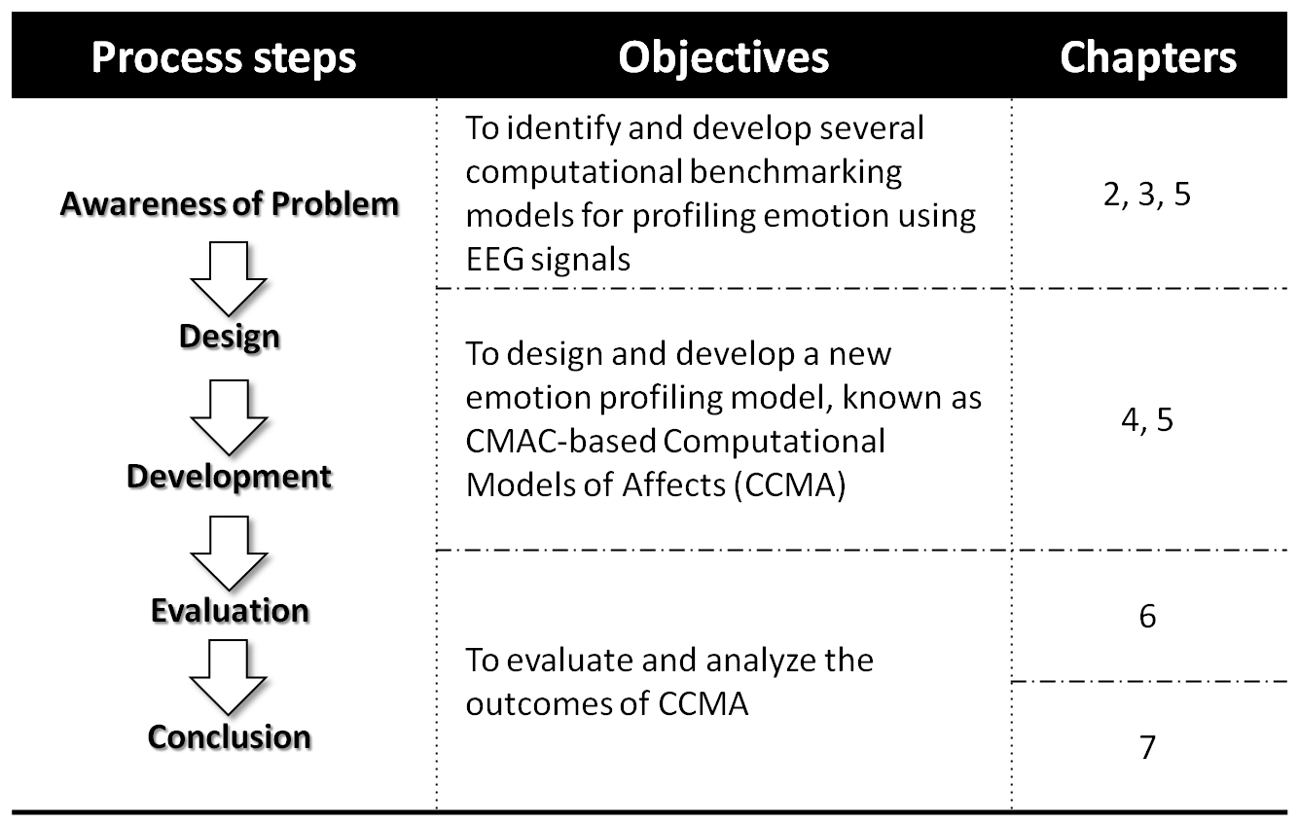

Figure 1.1 Example of Figure. Title below the figure

Table 1.1 Example of Table. Title above the table

|  |  |  |  |
| --- | --- | --- | --- |
| Research Questions | | Research hypotheses | |
| 1. | How emotion profiling can be implemented using EEG signals? | 1. | Emotions are generated at the brain. |
| 2. | Emotions can be measured based on categorical and dimensional models. |
| 3. | Emotional facial expressions of the peers are perceived differently that the faces of persons from different age groups. |
| 2. | How does CMAC appropriate for emotion profiling? | 1. | CMAC is inspired by the physiology and anatomy of the human brain through self-organization feature mapping (SOFM) |
| 2. | CMAC inherits the capabilities to solve non-linear problems |
|  | 3. | EEG signals which are chaotic and non-linear as well. |
| 3. | How to measure the performance of the profiling model? | 1. | As a classifier, the profiling model can be evaluated based on the accuracy measurement |

# REFERENCES

A.M. Martinez, & R. Benavente. (1998). The AR Face Database (No. 24).

Abdul Muthalib, A., Abdelsatar, A., Salameh, M., & Dalle, J. (2011). Making learning ubiquitous with Mobile Translator using optical character recognition (OCR). In 2011 International Conference on Advanced Computer Science and Information System (ICACSIS) (pp. 233–236).

Albus, J. S. (1975). A New Approach to Manipulator Control: The Cerebellar Model Articulation Controller (CMAC). Journal of Dynamic Systems, Measurement, and Control, 97(3), 220. doi:10.1115/1.3426922

Albus, J. S., Branch, D. T., Donald, C., & Perkel, H. (1971). A Theory of Cerebellar Function.

Alias, S., & Muhammad, S. K. (2013). Sequential pattern based multi document summarization #x2014; An exploratory approach. In 2013 International Conference on Research and Innovation in Information Systems (ICRIIS) (pp. 85–90). doi:10.1109/ICRIIS.2013.6716690